As Faith Builds Love for the Master Keeps Growing
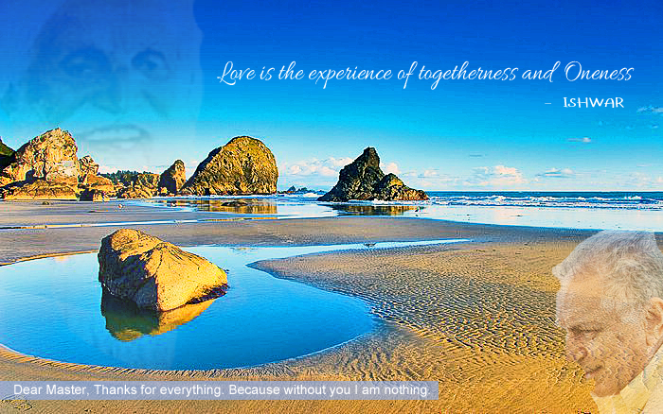
If a person is hoping this is her last life in a physical body, what’s the best way after initiation with a PLM to avoid generating more karma that might bring on another lifetime in the physical? Fulfill desires? Sublimate?
Q

No, the answer is simple. After you get initiated, hand over all the decisions to the master. Anything that happens, “Master, you do it.” No karma. If there’s any karma, it’s on the master. Fair enough. If he has initiated you, become your friend, that’s the minimum he should do for you - relieve you of your karma. And this is a way of living, a way of life, that you surrender the decision-making to your master. If one doesn’t have a master and doesn’t want to create more karma, surrender to whoever is your isht or your god or who you worship. Say, “Lord it’s in your hands. You take care.” And whatever the lord’s will, follow it. Distinguish lord’s will or master’s will from your mind’s will. Where your mind thinks and decides this is what I should do no matter what, that’s the mind’s will. If you go with the circumstances, what they indicate you should follow, that’s God’s will.

Maulana Rum, popularly called Rumi, he was asked this question, “Malauna, how do we know what is mind’s will and what is God’s will? Isn’t everything God’s will? Isn’t our mind also functioning under God’s will? Then how do we distinguish?” He said, “Mind’s will is when you think about it and take responsibility for a decision. Lord’s will is when he gives you something in front of you, do it. If he hands over a spade to you, he has expressed his will. Dig. If he has given a pen in your hand, he has expressed his will. Write. The circumstances around you dictate what is God’s will. If you go with the flow …” I remember this expression when I first came to America. It was very popular. Go with the flow. And nobody understood what going with the flow meant. Go with the flow means go with the will of nature, of God, of the creator, which is being revealed to you at all moments by what is in front of you. If something has to be done, do it. If you dilly-dally, think about it, that’s not God’s will. Then you create karma. So, therefore, if you live in the will of the lord and go with the flow, you create no karma.

Karma is only created when you have to deliberate between different choices and then you decide that’s what my mind says I should do. Then you create karma. Karma is created by the mind. It’s suffered by the mind. The rewards of it are benefited in the mind. It’s only a mental game. But if you go with the flow and go with God’s will, you don’t create karma.

What is the benefit of getting initiated by a perfect living master? The benefit is you have now a human being, not an unseen god, not somebody in your speculation, somebody in your imagination, but an actual person here who says, “I am your friend and I take responsibility for you. I take responsibility to take you out of this mess, go to your true home.” Well, let him take all the responsibility. Somebody asked Great Master, “Master, when we make daily decisions, we have to decide every day, things to do, how do we know which one to leave to you and which one to leave to me, to ourselves? And he said, “You can leave everything to the master.” But the mind doesn’t want to do that. Mind says, “Master, I need your help. I can do it, but I need divine intervention. I need some help from you to do it.” He said, “That is still your mind’s will.” But when you say, “Master, you are in control. I’ve surrendered to you. You take a decision.”

Supposing you are still in doubt, “Have I properly understood what is master’s will?” Then ask the master. Ask personally, if you know him physically, and are available to talk to him physically. He is available to you. Ask him physically. Is that your will or was my mind making it up? And if he is not physically available, then you take advantage of the benefit of initiation, because initiation gives you the power to contact your master inside at any time - 24/7. He gives you a mantra, a simran. He gives you empowered words, which are empowered by him, putting his own power into it and when you repeat those words and talk to the master, he will listen. What he says then is his answer to you. Try it out. So there are many ways initiation is a great benefit to transfer all responsibilities of your actions to your master. That is what a true friend is like. A true friend helps you whenever you need him. And the master does that. So if you are initiated, you can lead a life of leaving everything, all decisions to the master - inside or outside - and you’ll create no further karma






